**Report for Assignment 2**

**Linear Regression Using Pseudo Inverse Method**

I implemented Logistic Regression Classifier on dataset “heart_failure_clinical_records_dataset.csv” which I imported from Kaggle.com. Here we are trying to find platelets from creatinine_phosphokinase data.

Here, I first wrote all calculation steps for Linear Regression using Pseudo Matrix Method and implemented on the dataset. Then I checked my result using LinearRegression Package from sklearn.

Steps are,

* After loading the dataset, we perform normalization on entries of dataset.
* Then we used train_test_split from sklearn.model_selection to split features and target in train and test variables.
* Then using beta_hat = np.linalg.inv(X_mat.T.dot(X_mat)).dot(X_mat.T).dot(Y) we computer the required pseudo matrix multiplication.
* The variable beta_hat contains the estimates of the two parameters of the linear model.
* We get, beta_hat= [2.61923277e+05 2.46588986e+00]
* And by using LinearRegression Package from sklearn we get two parameters [261923.27722818268 2.46588986]

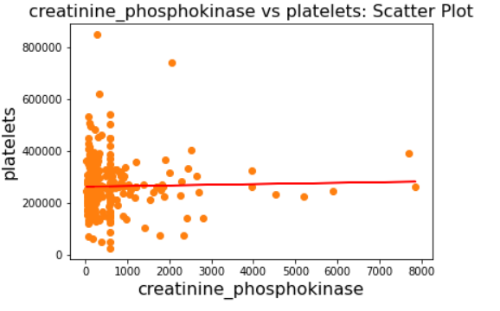

**Linear Regression Using Gradient Descent Method**

I implemented Logistic Regression Classifier on dataset “housing.csv” which I imported from Kaggle.com. Here we are trying to find maiden house value from features data given.

Here, I first wrote all calculation steps for Linear Regression using Gradient Descent Method and implemented on the dataset.

Steps are,

* After loading the dataset, we perform normalization on entries of dataset.
* Then we wrote main gradient_decent function here.
* Then we used train_test_split from sklearn.model_selection to split features and target in train and test variables.
* After implementing gradient_decent function in training data we get value cost function as 0.02325241790276246 and we got the required predicted maiden house value in normalized form.